EU-strategy seminar 27 June
Time: 27 June 9.00-15.00
Location: the Guild office, Rue du Trône 98, 1050 BRUSSELS
Programme
Developing competitive research strategies are crucial for the success of research organizations and teams in realizing scientific excellence and meaningful impact. Competitive research strategies have a perfect balance between building upon existing internal strengths such as successful research themes and unique infrastructure and adapting to a changing landscape such as the ability to integrate innovative technologies and attract the next generation of talented researchers. Having strong research strategies in place will improve the visibility, increase funding success and lead to new collaborations.
But how should such a strategy be developed? How can we adapt to a changing research landscape? How can I confirm my strategy is viable and ensures long-term competitiveness?
The Research Strategy and Funding Canvas which helps research organizations and teams to map their key competencies and capabilities, provide insight in current gaps and challenges and help strategizing for the future. The Canvas generates the unique ‘fingerprint’ of the organization and uses a unique 360-degrees stakeholder analysis to develop competitive research and funding strategies that are tailored to the research organizations and team. It is therefore a key tool to ensure your research organization and teams are optimally prepared for the future.
The Research Strategy and Funding Canvas consist of nine factors and key performance indicators. The Canvas can be used to develop competitive research strategies, measure performance and develop personalised funding roadmaps. It is based on a careful analysis of over 250 grant applications and best practices from almost 10 years of working with high performing research teams and organizations.
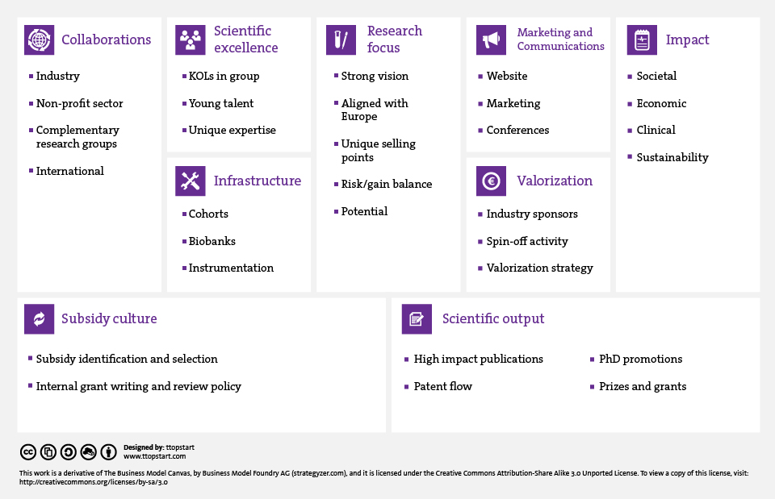
In this workshop we will leverage on this Research Strategy and Funding framework, to discuss several important elements that need to be developed to realise an effective strategy to be successful in Horizon 2020 and the coming Horizon Europe.
Start 9.00
9.00 – 9.45: Welcome and introduction (45 min)
- The programme (10 min)
- Introduction to the Research Strategy and Funding Canvas (15 min)
- Different sub-programmes and different success factors of Horizon 2020 and Horizon Europe (ERC, Marie Curie, INFRA, Industry Leadership, Societal Challenges) (20 min)
9.45 – 10.30: Research Focus - It starts with YOUR coherent institute wide Vision and strategy (45 min)
- Case Study 1 ERC – University of Bergen tbc: Vision, aligned with Europe, USP’s and success case EU proposal ERC – how did strategy turn into a valuable EU project, and how did it align with Europe’s vision and strategy? (+ Q&A, 15 min)
- Case Study 2 Marie Curie– University of Oslo tbc: Vision, aligned with Europe, USP’s and success case EU proposal Marie Curie – how did strategy turn into a valuable EU project with which partners, what were practical bottlenecks if any and how did you overcome them?
(+ Q&A, 15 min)
- Case Study 3 Societal Challenge – NORCE tbc: Vision, aligned with Europe, USP’s and success case EU proposal Societal Challenge – how did strategy turn into a valuable EU project with which partners, how did you find them, especially focus on application/industrial partners?
(+ Q&A, 15 min)
-------------- 10.30 – 10.45 (ca.) Coffee break -----------------------
10.45 – 11.15: Break-out sessions
- Breakout Group 1: how to improve alignment with EU vision and strategy – propose 3 SMART* Actions to develop and improve your H2020/H-EU strategy, inspired by the Canvas
- Breakout Group 2: how to improve strategic partnership building in Europe and beyond, to enhance success chances of projects and proposals – propose 3 SMART* Actions to develop and improve your H2020/H-EU strategy, inspired by the Canvas
- Breakout Group 3: how to improve impact of your research and EU projects in the domain of ARCTIC Research - propose 3 SMART Actions to develop and improve your strategy
11.15 – 11.45 : Plenary feedback session
- Feedback of breakout groups: 10 min per Group
----------------- 11:45 Lunch ------------------------
12.30 .00 – 13.50 : Internal organisation
- Introduction to the second part of the day (20 min)
- Case Study 4: NERSC - H2020 and H-EU strategy – How to get organised internally (15 min)
- Case Study 5: NILU tbc - H2020 and H-EU strategy – How to get organised internally (15 min)
- Breakout Groups 3x: how to improve internal organisation to streamline the operational H2020/H-EU strategy towards clear division of roles and efficient allocation of resources – propose 3 SMART* Actions to develop and improve your internal organisation
13.50 – 14.45: Plenary feedback session and discussion + follow-up activities
14.45 – 15.00: Wrap-up and closure
End 15.00

*SMART = Specific, Measurable, Actionable, Reasonable, Timely

