Ocean observing technology and data management
Research School for Master and PhD students
Longyearbyen and cruise with KV Svalbard
21-29 June 2020

Organisers: Nansen Environmental and Remote Sensing Center (NERSC), Department for Earth Science (UiB GEO), Department for Physics and Technology (UiB IPT), Geophysical Institute (UiB GFI), Western Norway University of Applied Science (HVL), University of Colorado (UC) and UNIS.

The research school is led by the Nansen Environmental and Remote Sensing Center under the project Useful Arctic Knowledge: partnership for research and education (UAK) funded by the INTPART programme 2018-2020 under contract no 274891. INTPART (International partnerships for excellent education, research and innovation) is funded by the Research Council of Norway and the Norwegian Centre for International Cooperation in Education. The project, which includes partners from Norway, USA and Canada, brings together leading researchers, educators and young scientists working on selected Arctic science topics. The research school is also part of the H2020 project INTAROS – Integrated Arctic Observation System, contract no 727890 (http://intaros.eu, http://intaros.nersc.no).

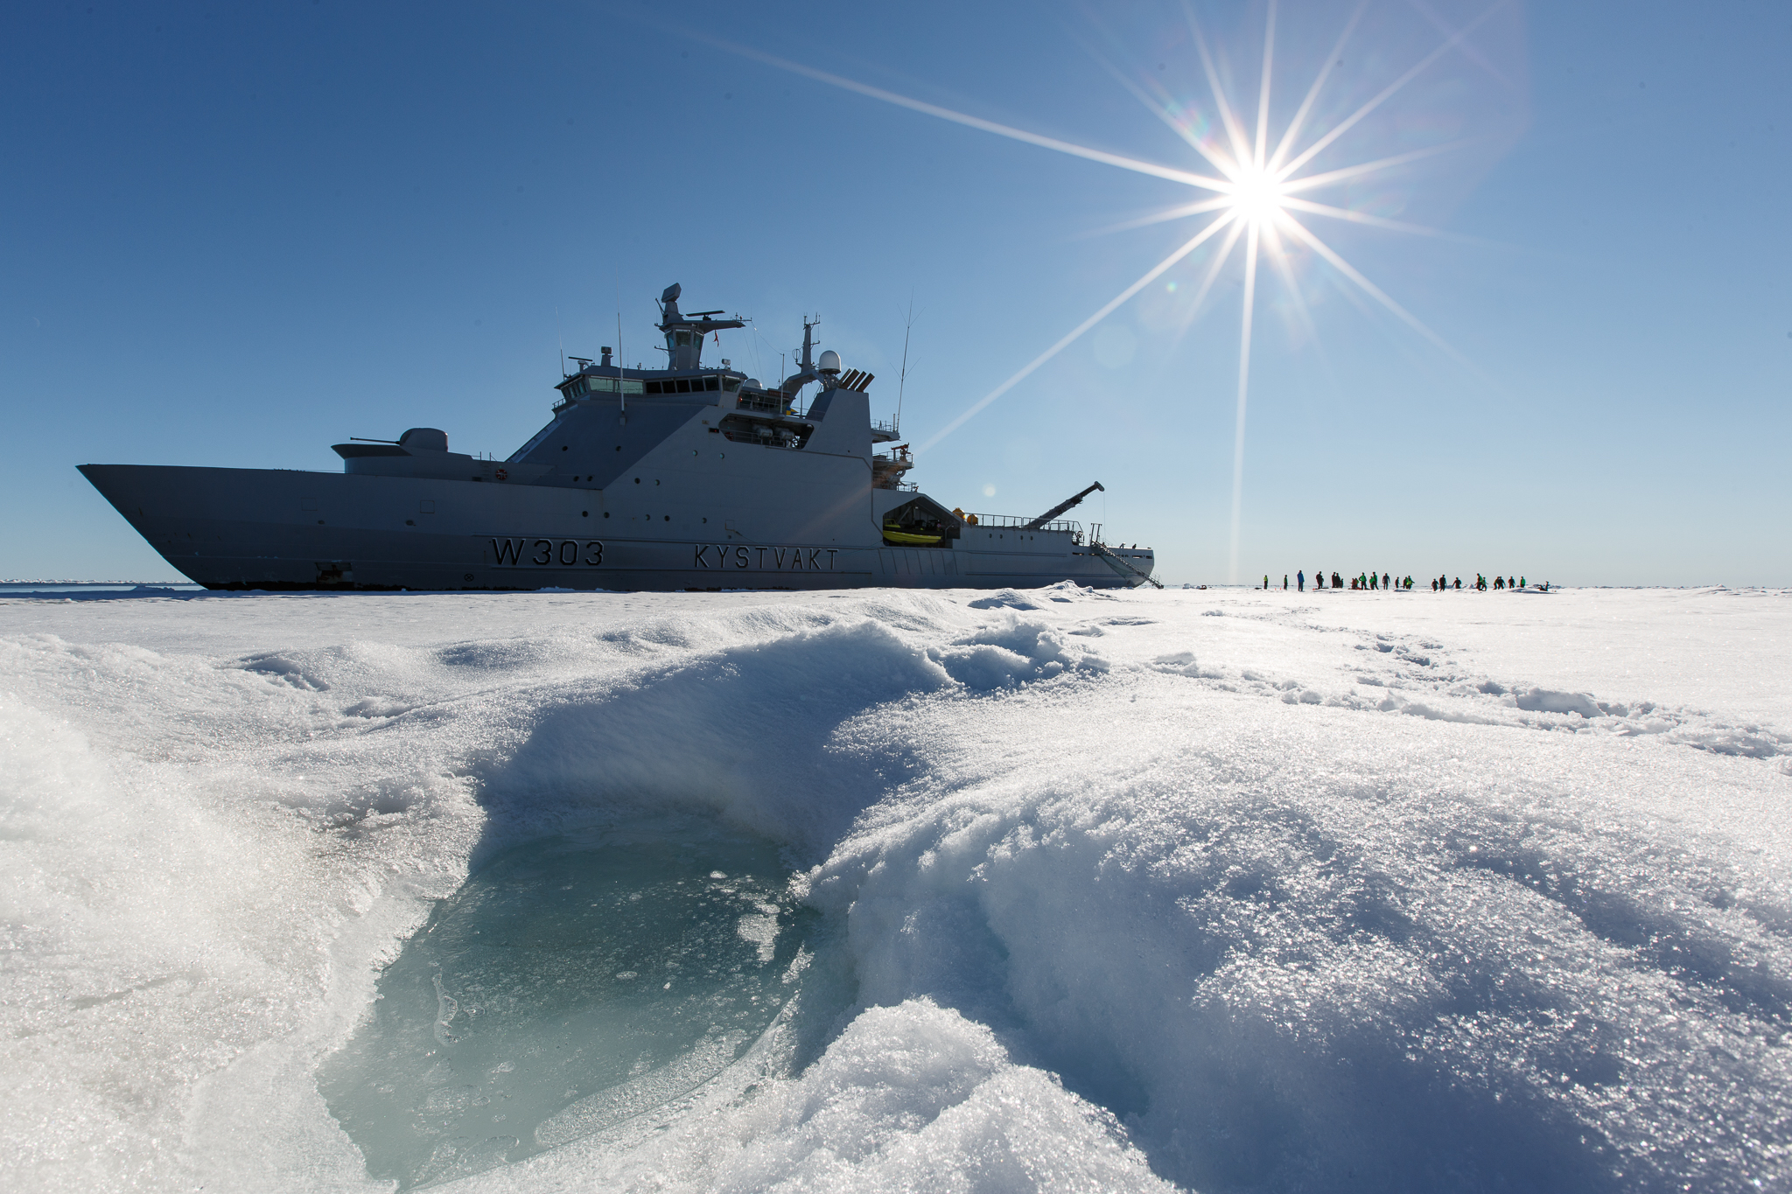

Figure 1. KV Svalbard icebreaker from the Norwegian Coast Guard. The photo is from a scientific cruise in the Fram Strait in 2016 (Photo: Håkon Kjøllmoen)

Brief description of the Research School

The UAK research school in 2020 will be held from 21-29 June onboard KV Svalbard during a cruise to Storfjorden (Fig. 2). The cruise gives the students a unique opportunity to learn about instrumentation, practical field experiments with data collection and data handling. The students are selected from the partner institutions, because we want them to have relevant background, such as in oceanography, ocean acoustics, ocean optics, seismology, other geosciences including instrumentation and data. There will be ca. 15 students and 6 -7 lecturers/instructors on the cruise.

Schedule for the research school

The schedule is the following:

19-20 June (Friday-Saturday): travel to Longyearbyen
21 June (Sunday). Introductory lectures at UNIS
22 June: go onboard KV Svalbard and departure from Longyearbyen
22-29 June: program onboard the ship (see description below)
29 June: arrival in Longyearbyen in the morning
29 June: depart from Longyearbyen in the afternoon

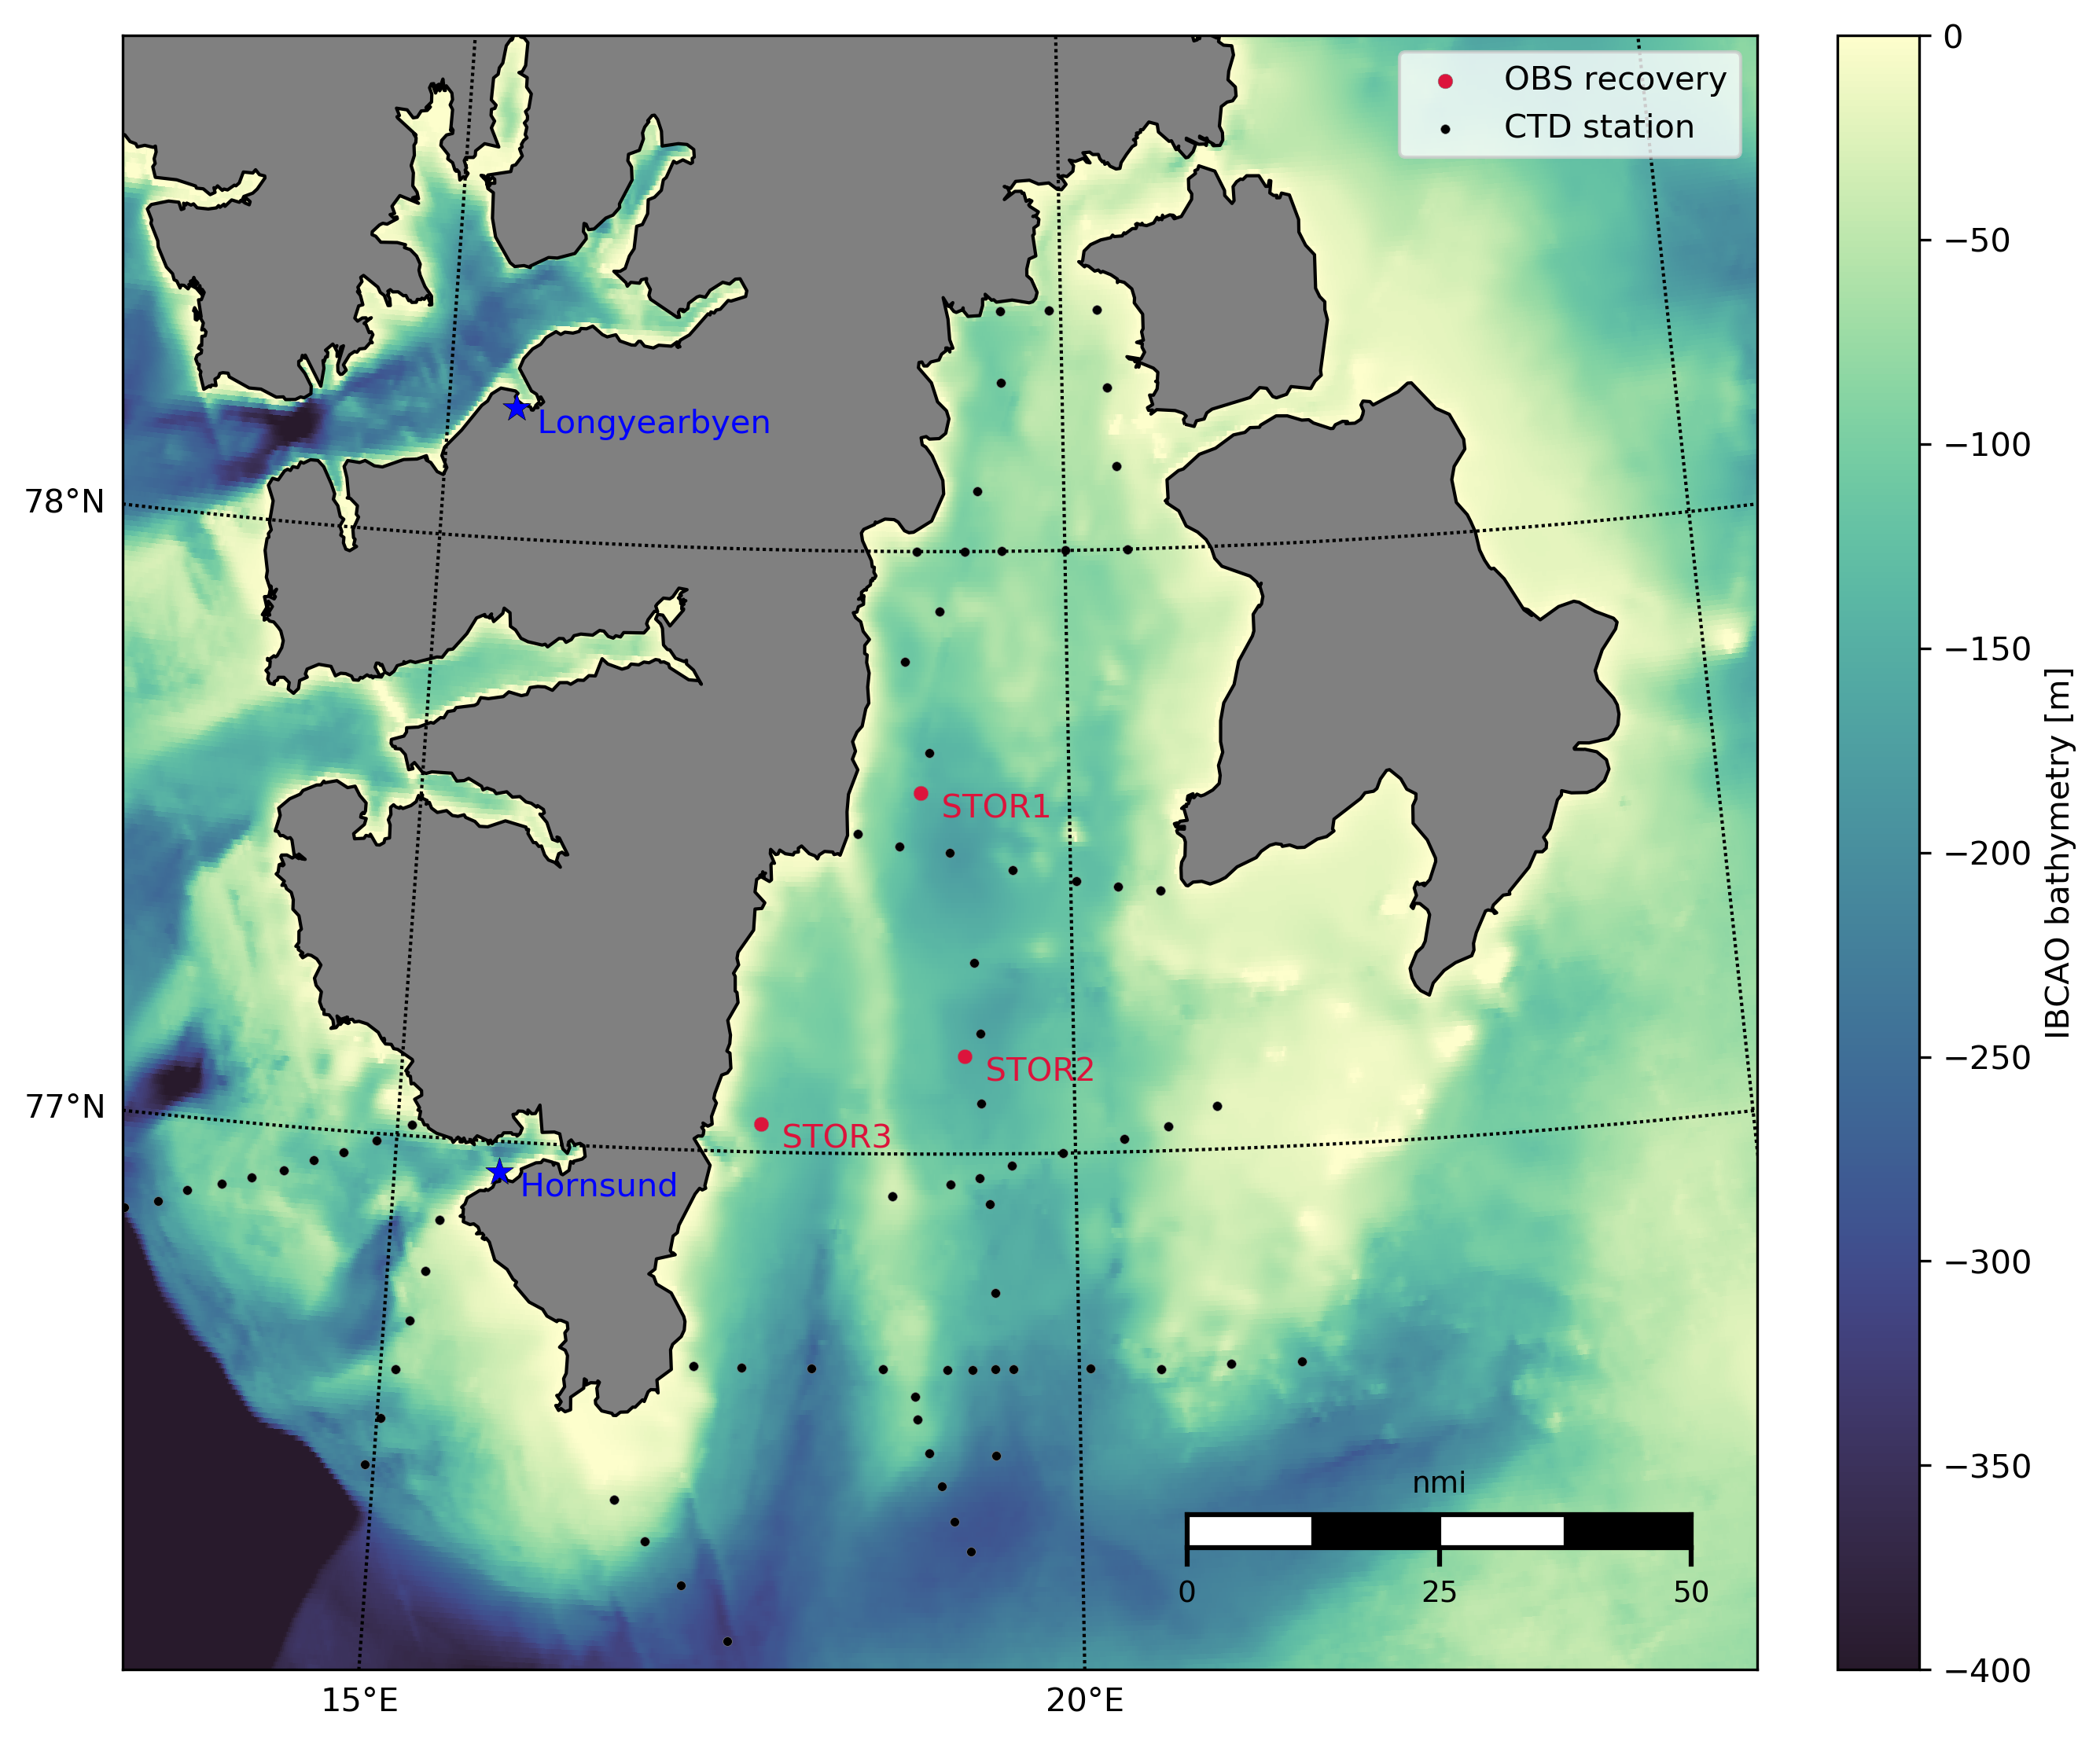

Figure 2. Map of Storfjorden with CTD sections occupied by UNIS (black dots) and location of three Ocean Bottom Seismometers (red dots) deployed by Department for Earth Science, University of Bergen
Brief description of the topics:

The research school will address the following topics in ocean observing technology and data management.

- Oceanography - measurements with CTD and water samples: Instructor: Eva Falck (UNIS) and Espen Storheim (NERSC). Lecture about the oceanography in the Storfjorden region. Lecture about the instruments (Espen), the measurements, processing and analysis tools. Carry out CTD measurements and analysis of the data. The data will be uploaded to a data repository with associated metadata, preferable to the Norwegian Marine Data Center (NMDC).

- Passive acoustics - measurements and data processing. Instructors: Espen Storheim (NERSC) and Kjell Eivind Frøysa (HVL). Some background about the acoustics i the Barents Sea and particularly in Storfjorden region. Some about the instruments, the measurements, experiment, processing and analysis tools. The Activity should lead to quality checked data at level 1, associated metadata. This should go into predefined data format from NERSC following guideline from IQOE.

- Marine optics - measurements of light in water. Instructor: Håkon Sandven (UiB IPT). Lectures about background marine optics, why it is important, how to collect data. And analyse data. Practical exercise in Barents Sea and particularly in Storfjorden region using instruments, carry out measurement experiments, processing data and using analysis tools.

- Seismology - measurements of earthquakes from Ocean Bottom Seismometers. Instructor: Mathilde Sørensen UiB-GEO

- Data processing and data curation of data collected in the four topics described above. Focus on preparing metadata for all the collected data using pre-defined templates. Instructors: Peter Pulsifer (U Colorado) and Frode Monsen (NERSC).

Outcome of the research school

The lectures given by the instructors will be available on the UAK website (https://uak.ucalgary.ca/) and the INTAROS website (http://intaros.nersc.no).

The students will prepare a report with description of the experiments, data collection, data management and scientific importance.

