3.1 Hydrosphere Infrastructures
The meeting was attended by:
DANUBIUS Adriana Maria Constantinescu
EuroARGO Claire Gourcuff
JERICO Laurent Delauney
EUROFLEETS+ Nicole Biebow, Veronica Willmott
ARICE Aodhan Fitzgerald
INTAROS Erik Buch (faciliatory), Stein Sandven, Agnieszka B. Möller, Mikael Sejr, Ruth Higgins, and Vicente Fernandez

3.1.1 DANUBIUS
DANUBIUS-RI’s Vision is to achieve healthy River Sea Systems and advance their sustainable use, in order to live within the planet’s ecological limits by 2050. DANUBIUS-RI’s Mission is to:
- facilitate excellent science on the continuum from river source to sea;
- offer state-of-the art research infrastructure;
- provide the integrated knowledge required to sustainably manage and protect River-Sea Systems.

DANUBIUS-RI’s goal is to overcome the current fragmentation of science, knowledge, data and management in rivers and seas by integrating spatial, temporal, disciplinary and sectorial thinking. It will provide science-based solutions to environmental and societal risks arising from global and climate change and will offer a source to sea perspective to resolve problems arising from human impacts on River-Sea Systems.

Many societal challenges related to River-Sea Systems are multi-faceted and require new approaches to research, spanning traditional disciplines, with a RI that:
  - spans the catchment from source to coastal sea
  - provides innovative opportunities for boundary spanning
  - facilitates knowledge exchange
  - attracts young people to science
  - maximises the impact of investments in environmental research,
  - driving innovation

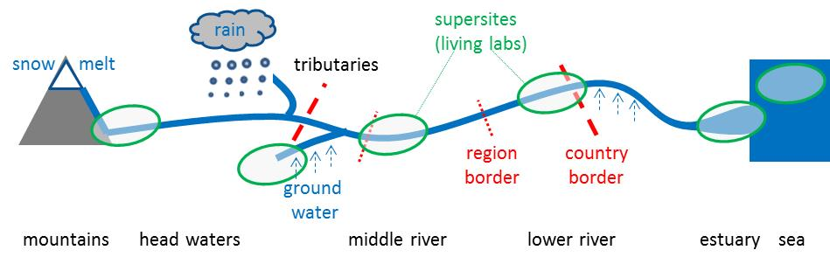

Guiding Questions for DANUBIUS-RI are:
- What constitutes a healthy River-Sea System in the Anthropocene?
- How are River-Sea Systems changing due to multiple and interacting pressures?
- How do processes and changes in parts of the River-Sea System propagate within the River-Sea continuum, both up and downstream?
- How are these changes affecting ecosystem health, its functioning and services?
- How can we sustainably balance use, protection and development of River-Sea Systems?
- How can we define and implement a management regime that can sustain the ecosystem services of a River-Sea System?

DANUBIUS work is implemented around the following components:

Observation Node:
Aims to:
- In-situ measurements and satellite imagery integration
- In situ sensor networks
- Real-time observations
- Water quality
- Emergent pollutants
- Biogeochemical cycles
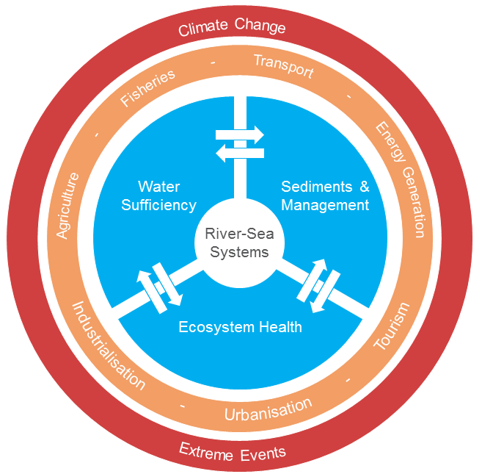
- Terrestrial coverage

The observation node is also responsible for:
- Standardization of field measurement equipment (in situ stations) and sampling in supersites
- Calibration
- Training

In the observation work there been identified a number of SUPERSITES:
- Natural laboratories for observation, research, modelling and innovation at locations of high scientific importance and opportunity
- Covering River-Sea Systems from river source to transitional waters and coastal seas
- Ranging from the near pristine (e.g. Danube Delta) to the heavily impacted (e.g. Thames Estuary)
- Identifying, modelling and defining system states and conditions for naturally and anthropogenically triggered transitions in the physical, biogeochemical and biological state

Observations are presently done in Europe i.e. no Arctic activities or plans; but the consortium is open to include observation sites in the Arctic in cooperation with relevant research groups.

Analysis Node:
Work focus on:
- Maintain amd update a set of harmonized common standards and analytical techniques implemented across DANUBIUS-RI to guarantee the quality and consistency of scientific output
  - methods
  - protocols
  - instruments
  - data acquisition
  - management
- Offers scientific expertise, laboratories and instruments
- Innovative methods for biotic and abiotic conditions and interactions
- Integrates disciplines from Geology, Hydrogeology and Hydromorphology, Chemistry, Biology, Ecotoxicology and Hygiene
- Working framework for all labs working with DANUBIUS-RI

Modelling Node:
Data from the Observation and Analysis Nodes and Supersites on morphology, process type and interaction between different large-scale (basin) or small-scale hydro-morphological processes integrated into models that:
- simulate the processes
- interpolate the measurements
- elaborate forecasts and scenarios

Provides methods and appropriate techniques that can be applied effectively in different Supersites and other locations

Impact node:
Constitute the link between society, relevant stakeholders and the scientific community to identify requirements for future work. It integrates technical knowledge with governance and policy-making to solve problems in complex River-Sea Systems:
- resolving problems
- confronting uncertainties in making decisions
- involving stakeholders
- bringing together different disciplines from different fields
- elaborating management scenarios

Data Management:
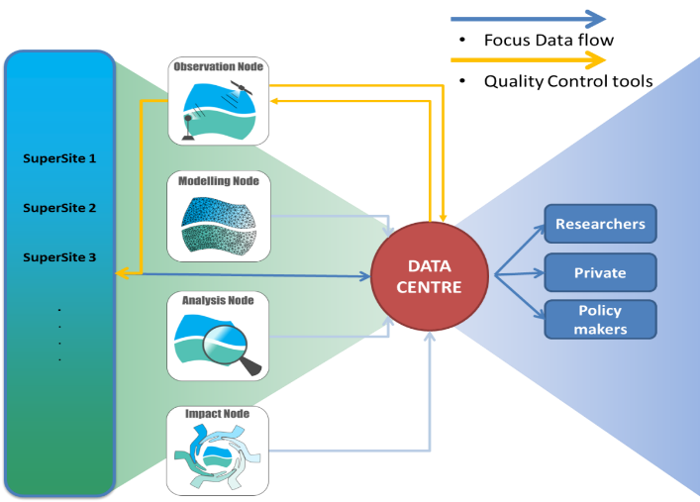
DANUBIUS operates a Data Centre that collects:
- Digital data from:
  - remote sensing
  - automatic stations (real time and periodic downloading)
  - cruises
  - computer models
  - physical, sedimentological, chemical, biological and ecotoxicological analyses
- Non digital data (e.g. biota samples, sediments, DNA)

Digital and non-digital data are stored at distributed data repositories but data information collected by the Data Centre. Research data stored, processed and made available (open access) to participants and public.

DANUBIUS has partners from 17 countries in Europe, including three international organisations/programmes. The work is funded via a H2020 Grant but consortium is in the process of becoming an ERIC – application was sent in August 2020.

3.1.2 EuroARGO
The Euro-Argo ERIC was created in May 2014 and has 12 member countries. Itis composed of:
- A central unit – Euro-Argo Office that is responsible for the overall coordination of Euro-Argo. It also participates in the procurement and deployment of floats; it has expertise in all aspects of the programme, and it acts as a resource centre for all participants and users
- Distributed national facilities - that are the participating Agencies, who operate with direct national resources. As part of the Euro-Argo ERIC, they agree to a multi-annual commitment of resources (in particular in terms of floats to be deployed and for the data system), and to coordinate their activities through the ERIC Office. All resources engaged by the National Agencies in support of Argo objectives will be considered as contributions to the Euro-Argo Research Infrastructure. The participating Agencies may be called upon to perform some activities under contract from the Euro-Argo ERIC, in particular some tasks necessary for the deployment and data management of European Commission funded float

Euro-Argo allows active coordination and strengthening of the European contribution to the international Argo programme. Its aims are to:
- provide, deploy and operate an array of around 800 floats contributing to the global target of one float per month in each 3° x 3° horizontal grid box (a European contribution of ¼ of the global array)
- provide enhanced coverage in the European regional seas
- implement the new phase of Argo, with extensions towards biogeochemistry, greater depths and high latitudes
- provide quality-controlled data and access to the data sets and data products to the research (climate and oceanography) and operational oceanography (e.g. Copernicus Marine Environment Monitoring Service - CMEMS) communities

Argo must be considered in its ensemble: not only the instruments, but also the logistics necessary for their preparation and deployments, field operations, the associated data streams and datacentres. That's why Euro-Argo establishes a high level of cooperation between partners in all implementation aspects:
- operation at sea, array monitoring and evolution,
- technological and scientific developments,
- improving data access for research and operational oceanography e.g. CMEMS,
- link to the international management of the Argo programme,
- promote Argo, enlarge the Argo data user’s community and help answering its needs.

The Euro-Argo currently has the means to acquire and deploy about 250 floats per annum and to monitor them appropriately. European deployment is undertaken via the efficient coordination of activities between members: the acquisition of floats is supported either by National Members or by the Euro-Argo Office through floats funded under European projects. The Euro-Argo Office offers the service of centralised float procurement at significant discounted rates, providing substantial value for members buying small numbers of floats per annum. The Euro-Argo technical team also conducts pre-deployment tests on the floats at IFREMER facilities.

The deployment of floats is carried out by Euro-Argo national members, usually in collaboration with neighbouring countries in the case of marginal seas. In the open ocean, Euro-Argo benefits from the support of international scientific collaborations.

Once floats are deployed, it is essential that critical technical parameters (i.e. energy budget, transmission power, battery voltage or data transmission) can be monitored. The Euro-Argo ERIC Office has developed an at-sea-monitoring system allowing continuous observation of floats’ technical parameters. This service allows the performance of instruments to be evaluated, and malfunctions to be detected at an early stage. An alert system has been developed to trigger corrections in delayed mode in the case of sensor drifts.

The Argo floats are not in its present version well-suited for use in ice covered waters like the Arctic Ocean since they have to surface on a regular basis to send data. So, the present Euro-Argo/Argo activity in the Arctic Region is primarily limited to the Nordic Seas.

For this reason, focus is on technical modifications of standard Argo-float enabling them to work in such ice-covered waters by adapting ice-avoidance algorithms or ice detection and ice-hardened antennas. Such floats are programmed not to surface during ice covered situations and store data to an internal memory in such situations. They will send the observations when they are able to surface. Technology for these ice floats has been developed already, and is tested under field conditions.

The standard Argo floats operate down to 2000m and only carry sensors for measuring temperature and salinity; but the ARGO community invest large resources in developing floats able to operate down to 6000m and carry several additional sensors especially biogeochemical variables.

Euro-Argo devote strong effort on delivery of data with the shortest delays possible and with extensive quality control. Hence there are real-time (less than 24hrs), near-real time (order of a few days), and delayed mode delivery systems. The quality control procedures are the highest and most stringent for the delayed-mode data stream which is designed to deliver data of climate quality.

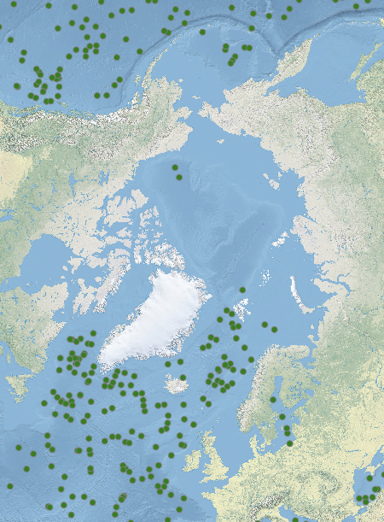
Formal data management procedures are implemented under the auspices of the international Argo Data Management Team. All procedures and data formats are fully compliant with recommendations from international bodies such as the WMO-IOC JCOMM. A network of centres is in charge of collecting and processing data from the floats and of delivering quality controlled data to users. All data are available to operational users via the WMO Global Telecommunication System (GTS) and also via Data Centres internet portals for all users. Euro-Argo ensures that:
- A free and open data policy relying on an organised data management system and an international community and applying the FAIR principle
- 100% quality-controlled dataset
- Two versions of Argo data:
  - Real Time data
  - Delayed Mode data
- NetCDF Format
- Apply to FAIR principles

Euro-Argo has formulated an ambitious 5-year strategy for the period 2019-2023 focussing on observing inadequately understood regions and properties of the ocean such as Polar Regions, deep-ocean and marine ecosystems that is of paramount importance for the European community. The strategy includes five objectives:

Euro-Argo has established strong cooperation’s with many relevant organisations within the field of marine observations. Do also reach out for new member countries f.ex Iceland and Russia – which could be relevant for future Arctic activity

3.1.3 JERICO
The coastal area is the most productive and dynamic environment of the world ocean, offering significant resources and services with many potentials for innovation and growth in the blue economy sectors. Coastal observations are important for improving our understanding of the complex biotic and abiotic processes in many fields of research such as ecosystem science, habitat protection, and climate change impacts. They are also important for improving our understanding of the impacts of human activities such as fishing and aquaculture, and underpin risk monitoring and assessment, but a major challenge in monitoring the coastal marine environment is to integrate observations of Essential Ocean Variables for physical, biogeochemical, and biological processes on appropriate spatial and temporal scales, and in a sustained and scientifically based manner.

JERICO-RI is an integrated pan-European multidisciplinary and multiplatform research infrastructure dedicated to a holistic appraisal of coastal marine system changes that is established and structured through JERICO-FP7 and JERICO-NEXT.

JERICO-RI, has gathered and organized key communities embracing new technologies and providing a future strategy, with recommendations on the way forward and on governance. Particularly, the JERICO community acknowledges that the main providers of coastal observations are:
- Research infrastructures,
- National monitoring programs,
- Monitoring activities performed by marine industries.
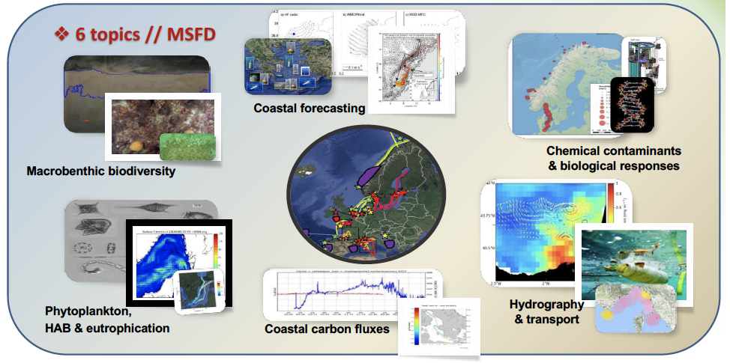
JERICO-RI aim to contribute to a better understanding of the functioning of coastal marine systems and thus to a better assessment of their changes caused by the combined effects of natural and anthropogenic changes. By 2030, the JERICO-RI aims to be the European gateway to long-term observations and related services for European coastal marine systems at the convergence between the land, open ocean and atmosphere; empowering European research excellence and expertise for the benefit of society.

JERICO-RI embraces emerging technologies which will revolutionize the way the ocean is observed. Developments in biotechnology (molecular and optical sensors, omics-based biology) will soon provide direct and online access to chemical and biological variables including in situ quantification of harmful algae and contaminants. Using artificial intelligence (AI), Internet of Things will soon provide operational platforms and autonomous and remotely operated smart sensors. Embracing key technologies, high quality open access data, modelling and satellite observations, it will support sustainable blue growth, warning and forecasting coastal services and healthy marine ecosystem. A substantial effort has been devoted towards establishing best practices on specific variables and instrumentations data treatment.

JERICO-RI has 40 partners from 19 European countries, the activities are focussing on 13 European regions where more than 500 platforms are operated. The JERICO-RI organisational setup covers the spectrum from in-situ observation, data management, delivery to data aggregation, data and product delivery to users. They have in this context established strong cooperation with other RI’s and ERIC’s in Europe, but have also established cooperation with similar initiatives in other continents around the Atlantic Ocean.

JERICO-RI do not at present have activities in the Arctic Region - except for the region covering the Norwegian coast - and it is not part of the strategy for the immediate future; but several partners of JERICO-RI do have observation activities in the Arctic so a potential for a future engagement is present.

The JERICO-RI community acknowledge the major importance of sound data management procedures, from acquisition to long-term archiving and open access following the Fair principle. For that purpose, JERICO-RI made a clear distinction between real time, near real time and delayed data. JERICO-RI has additionally proposed the creation of a JERICO accreditation label acknowledging a set of criteria ensuring that some standardization and interoperability, and the quality of data for coastal observatories are set. These include sustainability, operability and interoperability, and observing purpose. Sustainability aims to ensure the existence of a minimum time-frame during which the system is operational and observations available. Operability and interoperability aim to check that the system is following the best practices during the whole process linking data acquisition and data management.

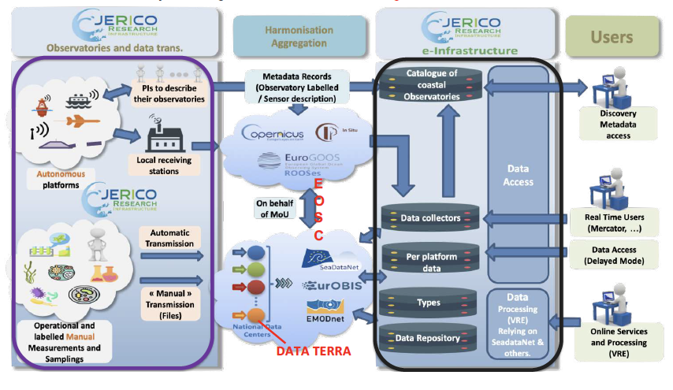

As part of the process towards becoming an ERIC JERICO-RI has performed a substantial user survey to collect an overview of requirements for products and services and thereby requirements for observations – the result is displayed in the figure below.

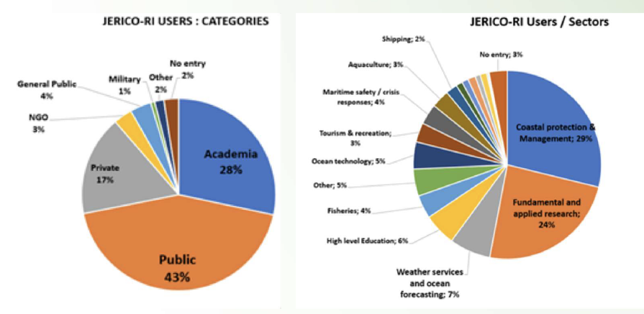

3.1.4 EUROFLEET
EUROFLEETS+ is an H2020 project funded under the Infrastructures initiative, that brings together a significant group of key marine research actors (in particular research vessel operators) in Europe, North America and Oceania – 42 marine institutes, universities, foundations and SMEs from 24 countries.

The EUROFLEETS+ project will facilitate open free of charge access to an integrated and advanced research vessel fleet, designed to meet the evolving and challenging needs of the user community. European and international researchers from academia and industry will be able to apply for several access programmes, through a single-entry system. EUROFLEETS+ will prioritise support for research on sustainable, clean and healthy oceans, linking with existing ocean observation infrastructures, and it will support innovation through working closely with industry.

The project will enable access to a unique fleet of 27 state-of-the-art research vessels from European and international partners. Through competitive Calls, researchers will be able to access the entire North Atlantic, Mediterranean, Black Sea, North Sea, Baltic Sea, Pacific Southern Ocean and Ross Sea. In addition to ship time, researchers will also have access to new AUVs and ROVs. In addition to comprehensive transnational access activities, the project will undertake joint research in challenging and highly relevant areas, including deep ocean research and exploration, data management, and enabling future virtual access. To maximise the impact of the project, EUROFLEETS+ will implement diverse training and education activities, strong management of innovation in collaboration with industry, and widespread dissemination and communication actions.

The EUROFLEETS+ project is a 4-year project running between 2019 and 2023, it has 42 partners. The objectives of the projects:
- Transnational Access Applications: Priority given to research on sustainable, clean and healthy oceans
- Linking with existing ocean observation infrastructures
- Support innovation through working closely with industry
- Training & Education – emerging scientists, technicians
- Stakeholder Engagement & Legacy Road Map

With the purpose to achieve the following impacts:
- Wider, simplified & more efficient access to the best research infrastructures irrespective of location
- Access to new of more advanced research infrastructure services enabling leading edge research
- Foster innovation through reinforced partnerships between research institutes and industry
- Development of synergies and complimentary capabilities across related research infrastructures leading to economies of scale through optimization of operations
- Education of the next generation of researchers so that they are ready to optimally exploit all of the tools essential for their research
- Better management of the continuous flow of data collected or produced by the facilities

Important components of the EUROFLEET implementation is:
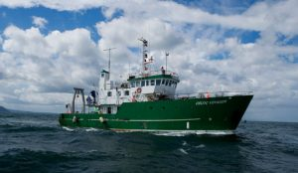
- Investigating and developing equipment and rigs for deep sea operations from vessels - exploration of the deep sea is a major challenge and opportunity in marine research. Rigs and related technologies are fundamental to the study of the sea as they are needed to deploy equipment. Therefore EUROFLEETS+ will conduct investigations concerning deep sea research from vessels aiming at achieving interoperability of rigs to be able to deploy different equipment, enabling installation of mobile equipment when needed, and facilitating sharing and installation of equipment across different ships.
- Developing innovative methods and strategies for intelligent exploration, mapping and control using cooperative navigation - innovative methods and strategies will be analysed and developed for intelligent exploration, mapping and control using cooperative navigation. New technologies will be developed for Autonomous Surface Vehicles (AUVs) and Autonomous Underwater Vehicles (ASVs) and the innovations will be validated prior to field testing during operational cruises. Focus is also on improved operational sustainability via reduced emissions from diesel engines, acoustically silent vessels, compliance in IMO Requirements and the Polar Code.
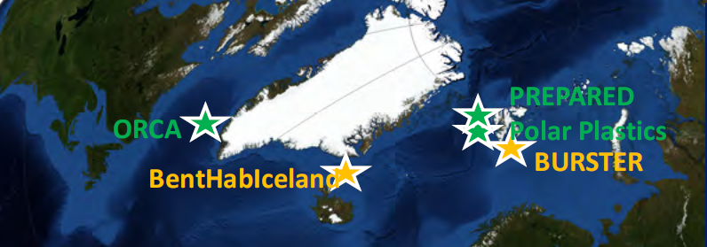
EUROFLEETS are actively supporting activities in the Arctic region. Since 2013 several cruises have been implemented primarily in Greenland waters and the Nordic Seas and 6 cruises are already planned for 2021 -23 period. Additionally, several of the research vessels being part of the EUROFLEETS+ perform their normal institutional operations within or at the rim of the Arctic region and 13 out of the 27 EUROFLEETS+ vessels are capable of working in ice infested waters.
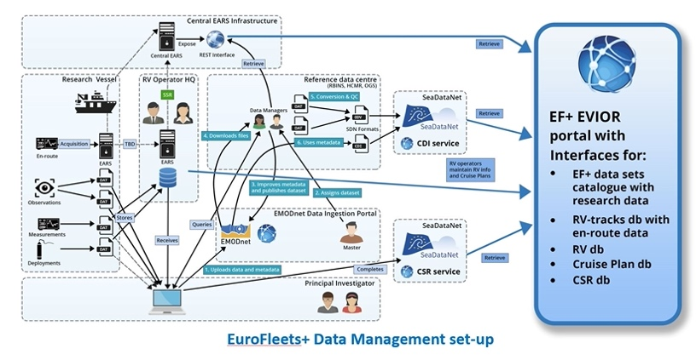
EUROFLEETS+ Data Management Policy for funded cruises is subject to the FAIR data Principles, so it works towards implementation of an active open data management strategy and associated procedures including adoption of SeaDataNet standards will ensure capture, transmission and publishing of information about the cruises, their data collection, and involved researchers, and data collected underway and processed later in time. Publication takes place through the EVIOR portal (European Virtual Infrastructure in Ocean Research – an integral part of the EUROFLEETS+ website) and the larger community SeaDataNet and EMODnet portals. The shipboard data management system, the (near) real-time transfer to shore, and the EVIOR portal for receiving and publishing metadata and data, will be advanced from their current state.

EUROFLEETS+ is working on a strategy for the period beyond 2023 which includes consideration on becoming a legal entity.

3.1.5 ARICE
ARICE (Arctic Research Icebreaker Consortium: A strategy for meeting the needs for marine-based research in the Arctic) is a H2020 funded project running from 2018 to 2022. The ARICE consortium of 14 partners from 12 different countries – 10 European plus Canada and USA. for marine-based research in the ice-covered Arctic Ocean.

ARICE´s overall goal is to provide Europe with better capacities for marine-based research in the ice-covered Arctic Ocean.

ARICE aims at reaching this goal with the existing polar fleet by:
- Networking - ARICE will develop strategies to ensure the optimal use of the existing polar research vessels at a European and international level. The aim is to establish an International Arctic Research Icebreaker Consortium which shares and jointly funds ship time for scientists on the available research icebreakers
- Transnational access - ARICE will provide transnational access to four European and two international research icebreakers. Access is granted based on scientific excellence of the research proposals; which researchers need to submit during the application process. The participating icebreakers are:
- PRV Polarstern, Germany
- IB Oden, Sweden
- RV Kronprins Haakon, Norway
- MSV Fennica, Finland
- CCGS Amundsen, Canada
- RV Sikuliaq, United States of America
- Joint Research Activities - ARICE will improve the research icebreakers’ services by working closely together with maritime industry on a so called “ships and platforms of opportunity” programme. Through this programme, commercial vessels operating in the Arctic Ocean will collect oceanic and atmospheric data on their cruises. At the same time, science and industry will work together to explore new technologies, which can improve ship-based and autonomous measurements in the Arctic Ocean. ARICE will also implement virtual and remote access of data via an innovative 3D Virtual Icebreaker, which will provide anyone with real-time information from the Arctic.

The work in ARICE is organised around 7 specific objectives:
- Harmonisation of the European Arctic research fleet
  - Improve the coordination of the available heavy icebreakers, the ice-strengthened RVs and the ice-classified RVs across Europe
- Develop an International Arctic Research Icebreaker Consortium
  - Multi-national collaboration on the planning and implementation of Arctic research cruises with heavy icebreakers
  - A European Consortium able to fund and implement cruises in the High Arctic
- Establish a regular dialogue with the maritime industry
  - To identify opportunities for collaboration between the science community and industry
  - Implementation of the Industry Liaison Panel (ILP)
- Educate a new generation of polar researchers and professionals
  - Targeted to PhD students, postdoctoral researchers, technicians and engineers
    - Online Training & resources for multiple audiences
    - MOSAiC School 2019 -6-week training on board RV Akademik Fedorov during 1stleg of MOSAiC expedition (+multiple training material, videos, …)
    - ARICE SUMMER School 2020 & technician training - planned for summer 2020 on board of RV Heincke & at AWI Helgoland but due to COVID 19 it was cancelled and will be implemented in 2021 as online training.
- Provide access to European and international research icebreakers in the Arctic Ocean
  - 8 project proposal out of 19 applications has been selected for funding. 4 cruises have already been implemented, the remaining cruises has been postponed due to COVID19 and is now planned for 2021.

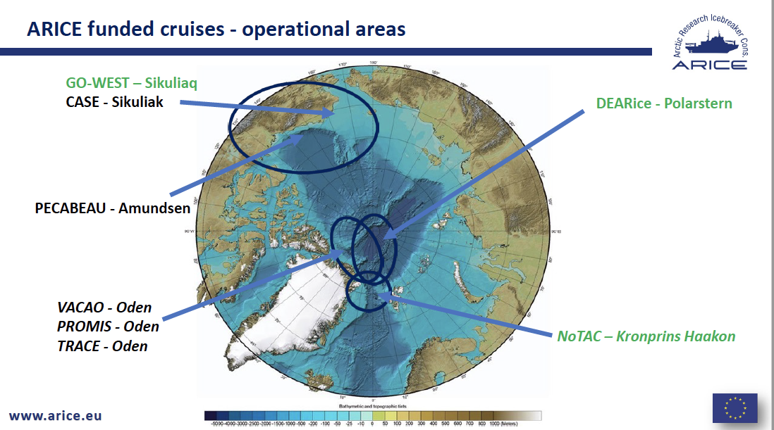

- Expand the monitoring and observation capacities in the Arctic Ocean (SOP programme)
  - Use the increase in marine traffic in the Arctic to:
    - implement a “programme of ships and platforms of opportunity” in the Arctic Ocean
    - to identify key technologies that could lead to an improvement of ship-based and autonomous measurements in ice-covered seas
- Enhance virtual and remote access to data
  - Establish the project data management system and develop and adapt strategies and tools for efficient data access and data dissemination
    - Data belong to the individual scientists but ARICE support open and free access to data according to FAIR principle.
  - Development of a “novel” 3D icebreaker to visualize data and research equipment.

ARICE has established cooperation to a large number of projects and since ARICE was formed out of EUROFLEET, because EU requested special focus on the Arctic, there are naturally closely linked to EUROFLEETS+.

3.1.6 Discussion
At the end of the meeting some cross-cutting items was discussed:
- Sustained funding
  - Infrastructures registered as an ERIC (legal entity) primarily rely on national contributions – financial as well as in-kind via national priorities activities. The advantage of being an ERIC is the possibility to apply for external funding.
  - The ships included in the EUROFLEETS+ and ARICE projects is operated and funded by national institutions – the two projects in principle buy/fund ship time for selected research activities. This implies:
    - Funding of the ships are fairly well sustained however based on national priorities f.ex. some of the icebreakers within ARICE soon needs replacement but this is presently not high on the agenda.
    - EUROFLEETS+ and ARICE is time-limited projects which put severe constraints on the continuity of support to research projects that need these platforms. This is especially problematic for Arctic science community since there are so few ships available that operate there. It is therefore important that the Arctic Science community unitedly put pressure on national and EU funding agencies to secure sustained availability of relevant observation platforms.
- Cooperation
  - All participants report on cooperation with each other and other relevant infrastructures especially on best practices, joint workshops etc. This cooperation is regarded important and needed to establish a coordinated observing system.
  - Cooperation with Russian institutions and colleagues is regarded crucial for the Arctic; but is for the time being difficult for political reasons. There are relatively good contact on a personal level but formalised cooperation needs actions on a high political level – a process that needs EU involvement.
- Requirements for observations (spatial and temporal resolution, timeliness and quality)
  - The Argo formulated in the 1990’ies clear goals for spatiotemporal resolution for the traditional floats and has achieved them in large parts of the world ocean. They now work on formulating equally ambiguous goals for deep and BGC floats. They believe these clearly articulated goals has helped them in getting funded.
  - All have focus ond formulating best practices on observing procedures , quality control etc. and this work is subject for coordination and cooperation between the various Research Infrastructures.

