EO Polar Science Workshop
Discussion Session Proposal: Sea-Ice

(Wolfgang Dierking (AWI), Leif Toudal (DTU), Einar Örn Ólason (NERSC), Laurent Bertino (NERSC), Stein Sandven (NERSC), Thomas Lavergne (met.no), Jerome Bouffard (ESA), Michael Kern (ESA), Marco Meloni (ESA), Ola Grabak (ESA)

High level description of the grand challenge
The overarching challenge is to improve the understanding of long-term Arctic and Antarctic-wide changes of sea ice cover as well as of dynamic interaction processes between ocean, sea ice, and atmosphere on different spatial and time scales. How do changes and variations of the sea ice characteristics affect the regional Arctic and Antarctic environment, weather, and climate? Which processes have to be considered to quantify the changes?
Key questions:
- Which progress related to EO of the Polar Regions has been achieved since the last ESA workshop? (See “Way-Forward” paper 2013 from the workshop 2012)
- Which still existing gaps in our knowledge can potentially be closed by means of new EO sensor technologies and new strategies for data acquisition and analysis?
- Which EO missions / mission combination have shown promising results?
- How can we effectively make use of atmosphere-sea ice-ocean interaction models, models describing the interaction between electromagnetic radiation and ice/water, and in-situ measurements obtained during field campaigns for enhancing the information retrieval from EO data?

Proposed introductory key notes (10 minutes each)
- Recommendations from last ESA (+Clic+…) Workshop(s): How did ESA implement the recommendations? Diego Fernandez, …
- Sentinel Extensions / HPCMs => 1-3 presentations on missions and their applications in Polar Research: how will they improve monitoring of the Polar Regions?, e.g. M. Kern (CRISTAL), C. Donlon (CIMR), M. Davidson (ROSE-L), …
- Understanding interactions between sea ice, ocean, atmosphere: which contributions can we expect from EO? Ron Kwok, Dirk Notz, …

General structure of session:
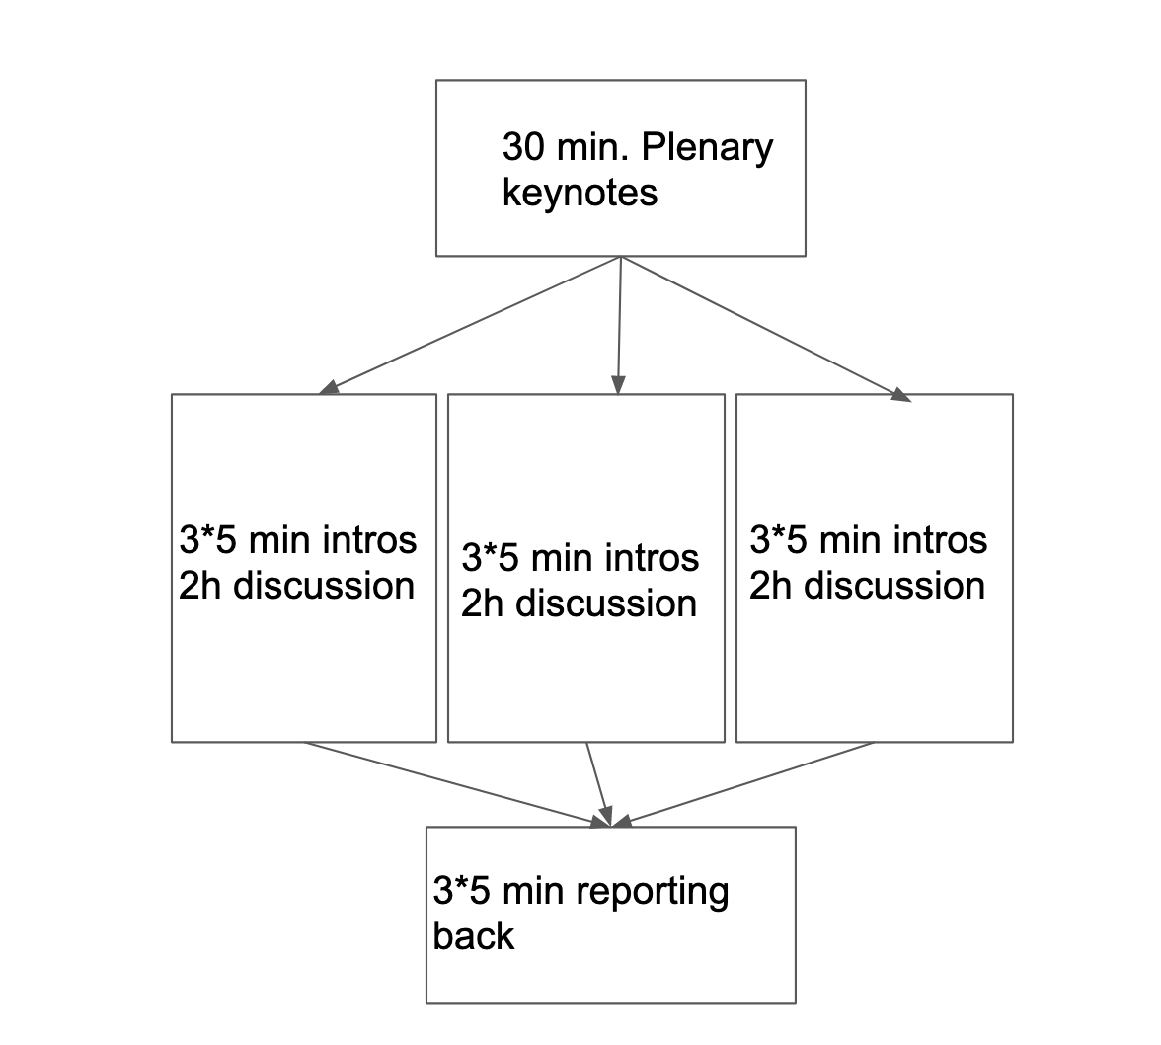

Splinter / Sub-challenge 1: Gaps in sea ice data EO-based products
Chairs: Wolfgang Dierking, Stein Sandven

Topic: Improvement of EO-based products (e.g. ice charts, spatial and temporal variations of ice properties, ECV data) in terms of increased information content, reliability, accuracy, timely availability, and temporal consistency?

Key questions:
- Which mission capabilities¹ and multiple-sensor combinations² show promising potentials for a given application (e.g. retrievals of ECVs, ice charting, ice drift/deformation retrieval, iceberg detection and tracking)?
¹e.g. polarimetric mode SAR and PMR, SAR interferometry
²e.g. passive microwave + SAR + altimeter for improved sea ice thickness retrieval; optical sensors, SAR and altimeter for iceberg monitoring; SAR + optical sensors + PMR for operational ice charting).
- Which are the major factors limiting our sea ice observation and parameter retrieval capabilities for different applications?
e.g. missing satellite technologies or data acquisition strategies, gaps in theoretical knowledge of radiation – matter interactions, lack of in-situ measurements
- How can the retrieval of sea-ice parameters, also including the ECVs, be improved/matured?
e.g. strategies for robust inter-comparisons exercises, requirements for climate and operational needs, current and future ESA and non-ESA initiatives, data assimilation and synergies with models, problems of and solutions for retrieving snow depth on sea ice

Suggested 5 minutes introductory talks
- User needs for sea ice information and required sea ice products: Nick Hughes (Met. No., PI for EU project KEPLER), Stein Sandven (NERSC), Gilles Garric (Mercator Ocean Intl representing CMEMS)
- Linking operational sea ice monitoring with needs in science: John Falkingham, International Ice Charting Working Group IICWG
- A tour of existing ECV Sea Ice capabilities, and questions that are still open (variables and EO techniques): Dirk Notz, U-Hamburg and CMUG, Thomas Lavergne (Met.No.), Stefan Kern (Univ Hamburg, CCI).

Splinter / Sub-challenge 2 Cal/Val Strategies

Chairs: Christian Haas (AWI), Fanny Girard-Ardhuin (IFREMER)

Topic: Field data collections and collection strategies (including helicopter/airplane) that are needed for EO-algorithm development and validation of products derived from EO data and for tuning of AI/ML techniques. The lack of validation data is one of the most serious problems when analyzing satellite data acquired over sea ice and developing algorithms for, e.g. ice type classification and retrieval of ice properties. The validation of Arctic / Antarctic-wide products requires the combined use of field measurements and high-resolution satellite data.

Key questions:

- New instrumentation and strategies for field and airborne data collections, and their impact on EO data retrievals, algorithm development, and cal/val?
e.g. use of drones / UAVs? Which sea ice parameters are important (application dependent, also including modelling of atmosphere – sea ice – ocean interactions and modelling of emission, scattering, reflection from sea ice)? Which gaps exist in measurement techniques, which improvements of measurement devices are necessary? Status of guidelines, standards, and manuals of field data acquisitions related to remote sensing? Should one further develop them?
- Suggestions of standards for data processing, data products, archiving and other data management issues of field campaigns?
e.g. which archives should be used to secure long-term preservation of the data? How to manage access to archives? Need for data rescue? Using data of operational ice services and/or ice-going vessels?
- Which criteria are needed for quality assessment of field and airborne data?
e.g. which information should be included in the documentation of field measurements? Methods for quality assessment?

Suggested 5 minute introductory talks
- New instruments and strategies for field measurements: Christian Haas & Stefan Hendricks AWI; Sebastian Gerland, NPI
- Field data for development and validation of EO retrieval algorithms and sea ice models: what is missing? John Yackel, Rasmus Tonboe, Eero Rinne
- Upscaling for improving parameter retrieval from wide-coverage satellite images: best strategies? Thomas Lavergne (Met. No.) Fanny Girard-Ardhuin (IFREMER), Frode Dinessen (Met. No.)

Splinter / Sub-challenge 3, Atmosphere – sea ice – ocean interactions: towards enhanced use and assimilation of EO data for improving Earth system models and models for regional and local short-term forecasts

Chairs: Einar Orn Olason (NERSC), Laurent Bertino (NERSC)

Topic: Modelling and forecasting of sea ice and ocean dynamics and conditions are based on (assimilation of) EO-observations. For climate research this is on hemispherical to regional scales, for operational ice services (ice charting for safety of marine operations) on regional to local scales.

Key questions:

- Which are the major limitations preventing accurate high-resolution sea ice and ocean forecasts in the Polar Regions?
e.g. do we need better models, better data and/or better data assimilation methods?
How do uncertainties in measured sea ice parameters affect model forecasts?
What spatial and temporal resolutions are required for different types of models?
- How can we use EO to improve model physics and parameterizations?
e.g. how realistic is it to predict, e.g., location of a lead/ridge for a given time? Which approach is promising (e.g. statistical)? Which of the recent EO products are most useful for model evaluation? Which EO products are missing to improve model evaluation?
- What improvements in EO are most relevant for improving data assimilation into sea-ice models?
e.g. improved spatial resolution, temporal resolution, or accuracy?

Suggested 5 minute introductory talks
- Atmosphere – sea ice – ocean interactions: recent understanding and gaps in knowledge: Ron Kwok, JPL, Frank Kauker, AWI
- Most recent model developments and synergy with EO data: Laurent Bertino and Einar Olason (NERSC)
- Assimilation of EO into sea-ice models, status, challenges and future prospects (Laurent Bertino, Anton Korosov (NERSC)
- Examples of discrete element models (Agnieszka Herman, Stéphane Labbé ).

