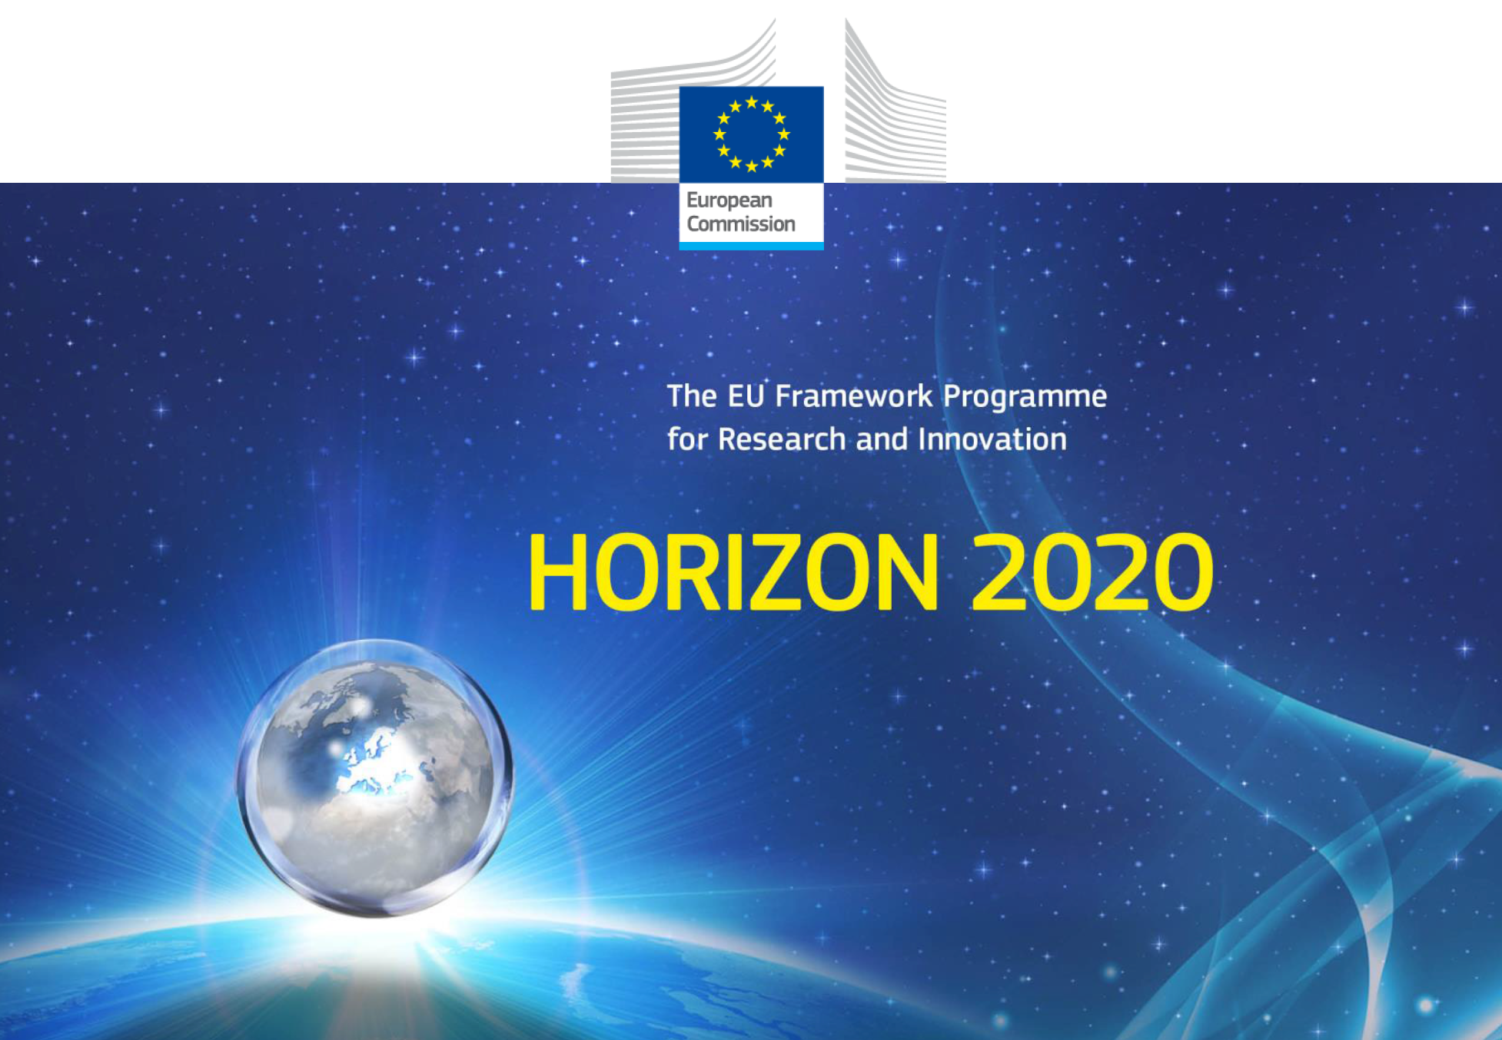

INTAROS Roadmap

for a sustainable Arctic observing system

Draft

17 December 2020

Contributors

Coordination and editing | Stein Sandven, Hanne Sagen
Atmosphere | Michael Tjernstrøm and Roberta Pirazzini
Ocean: Physical Oceanography | Agnieszka B.-Möller, Marie-Noelle Houssais
Biology-biogeochemistry | Geir Ottersen, Mikael Sejr, Truls Johannessen
Sea level | Ole B. Andersen
Observation technology | Thomas Soltwedel
Sea ice: | Georg Heygster
Terrestrial themes: Glaciology | Andreas Ahlstrøm, Francisco Navarro
Snow, hydrology | Roberta Pirazzini, David Gustavson
Land cover and fluxes | Shaun Quegan, Donatella Zona, Mathias Goeckede
Cross-cutting: CBM/Citizen science | Finn Danielsen, Lisbeth Iversen
Natural hazards | Mathilde Sørensen, Peter Voss
Data systems | Torill Hamre, Peter Pulsifer, Pedro Goncalves
Stakeholder engagement, dissemination and exploitation | Ruth Higgins, Erik Buch, Donatella Zona
Other | Eija Asmi, Jean-Pierre Gatuso

Contents

1. Introduction 2
2. Strategies, objectives and requirements for Arctic observing systems 2
2.1 Scope of the observing systems 2
2.2 Users and their requirements, differentiating between user categories 2
2.3 Priorities within the scientific disciplines and what should be minimum standards 2
2.4 International agreements, legal issues 2
3. Physical infrastructure, platforms and sensors 2
4. Implementation and operation of the observing systems 3
5. Data production, dissemination and management 3
6. Organisation – the role of various actors 4
7. Governance and funding 4
8. The main challenges in implementation of Arctic observing systems 4
8.1 Land-based systems 4
8.2 Ocean-based systems 4
9. Useful links and background documents 5
Global programmes 5
Arctic programmes 5
Appendix A: INTAROS Task 1.5 5
Appendix B: EU consultation on Ocean Observation 6
Target audience 6
Why we are consulting 6

Introduction

One of the specific objectives of INTAROS is to “Develop a roadmap for a future sustainable Arctic Observing System”.
The Roadmap will take into account
….”the roadmap ….. will be based on the synthesis of all results from INTAROS and describe solutions for implementation in the next 10 years”
….”planning and implementation of research infrastructure projects (RIs) on European level (e.g. ENVRI-FAIR) and national level (e.g. Arctic research stations, German FRAM programme)
… “the roadmap …. will adhere to plans pursued by nations who are, and plan to be, actively involved in Arctic observing activities”
….”the roadmap will support EU Arctic policy, including the updated version to be published in 2021”.
….”involvement of stakeholders………”
….”planning and implementation of research infrastructure projects (RIs) on European level (e.g. ENVRI-FAIR) and national level (e.g. Arctic research stations, German FRAM programme)
….”… will include both scientist-executed and community-based observing”

Strategies, objectives and requirements for Arctic observing systems

There are plenty of background documents, so we need to make a summary chapter, making reference to strategies, objectives, roadmaps and implementation plans in existing document (see section 7. Useful links). Issues to be addressed are:

2.1 Scope of the observing systems

with focus on the in situ component complementing the satellite and other remote sensing systems for observing climate, environment, and related topics

2.2 Users and their requirements, differentiating between user categories
Priorities within the scientific disciplines, including what should be minimum standards

2.3 Priorities within the scientific disciplines and what should be minimum standards

2.4 International agreements, legal issues

Physical infrastructure, platforms and sensors

What exist, what is evolving, and what can be expected to available in 10 years ?
Technology development as driver for new observations
Maturity and robustness (TRL-level) of platforms/sensors and adaptation to Arctic conditions,
Logistical issues, communication and safety of operations

- Satellite observing systems (refer to the Sentinel programme and other space agency EO-programmes) Michael: Atmospheric observation by satellite is often forgotten in this context; important that we don’t do that here. Satellites observe much more than sea ice and ocean parameters and is of particular importantce to the atmosphere in light of the lack of almost everything else over the Arctic Ocean.
- Marine-based observing systems
Ship-based
Underwater platforms (Agnieszka: I would rather use: fixed underwater platforms and mobile platforms, the latter ones including ice-based platforms, underwater and surface drifters (inc. Argo) and autonomous devices as gliders and AUVs
Ice-based platforms
- Land-based observing systems
Research stations, ranging from complexed manned stations to simple, automated platforms
with a few instruments
David: National monitoring systems, such as river gauging stations for hydrological observations. It is not only research stations. Some of the national monitoring stations are also part of international networks, but not all of them.
- Other systems: aircraft, drones, cables
- Existing international networks, such as those under WMO/WCRP/WWRP, e.g. GOS, GAW, Arctic-HYCOS, etc.

Implementation and operation of the observing systems

- Divide into land-based and ocean-based systems
- Complementing satellite-based systems
- Variables to be observed, ranging from basic standard variables to new or advanced variables (Agnieszka: Should we also touch upon EOV/ECV/EAVs? Process of defining them, requirements, high-level guidelines?
- Multidisciplinary systems – collaboration across scientific disciplines (Agnieszka: Expandable systems in future? Central nodes with capacity for plugged-in sensors?
- Range of systems from automated/autonomous to human-operated systems
- From ad hoc research observations to operational data production systems.
- Engagement of citizen science and community-based observing systems
- Observing strategy, sampling in space and time, logistical constraints
- Existing networks and further network building

  - Atmospheric observing system
Michael: Important to not focus just on surface variables but also the entire atmosphere, including the vertical structure. The synthesis report (D2.10) had a different structure, where all observing systems were divided into Arctic Ocean and Arctic land, due to the logistic differences; all serious observing over the Arctic Ocean require a marine platform. The implementation and operation of atmospheric systems in the Arctic Ocean is therefore more challenging over the ocean than over land.
  - Ocean observing systems
  - Terrestrial observing systems
Roberta: I also feel that the keeping the division between Marine and terrestrial Arctic (as done in Section 3) is more practical, also in the context of multidisciplinary platforms (ships and buoys are used for ocean, sea ice, and atmospheric observation in the marine Arctic, while towers are used for atmospheric and snow/surface observations over the terrestrial Arctic)

Data production, dissemination and management

- Handling data on sensor and platform level,
- Existing best practices for data collecting/processing with a focus on specific Arctic environmental conditions?
- Near-realtime data versus delayed mode data
- Ensuring all data has a license acknowledging the producer and describing the permitted use of data
- Documenting data according to best practices, using established metadata standards and vocabularies
- Preparing data in standard formats for publication through sustained data repositories offering DOIs
- Delivery of data to users and exchange of metadata between data infrastructures and portals

  - Atmospheric observing system
  - Ocean observing systems
  - Terrestrial observing systems

Organisation – the role of various actors

Who are the actors to implement and operate the systems ? Provider side and user side
What are their role today and how should it be improved ?
Michael: Important to consider both operational and research networks, and also those “in between”, e.g. infrastructure networks (super sites) that can serve both.

Ruth: Perhaps we should add here something about other projects, programmes and initiatives with notes on co-design on cooperation and collaboration. Again following the flow of what exists and where, mapping the landscape of Actors, and seeing where things are headed, as well as describing the cohesive and inclusive “ideal” system.
I think Erik and I could work together on this, focussing on Engagement, Dissemination and Exploitation of outputs.

  - Atmospheric observing system
  - Ocean observing systems
  - Terrestrial observing systems

Governance and funding

- Governance issues – see SAON ROADS process

- Funding issues
What is the funding structure today and how is it expected to evolve in the next 10 years ?

Michael: Consider the climate; observing in the Arctic is part of global observing and has importance that goes well beyond Arctic interests

Agnieszka: Are we going to estimate “required level of funding to establish a comprehensive future observation system for the Arctic” as described in the T1.5 text (App. A)? If so, it should be included here in connection to funding issues. But the question is – are we able to provide such estimates?

The main challenges in implementation of Arctic observing systems

Land-based systems

8.2 Ocean-based systems

Useful links and background documents

Global programmes
Global Climate Observing System – GCOS: https://gcos.wmo.int/
Global Ocean Observing System – GOOS: https://www.goosocean.org/
Global Cryosphere Watch - GCW: https://globalcryospherewatch.org/
WMO Data Conference 16-19 Nov (https://public.wmo.int/en/events/WMO-Data-Conference)
+

Arctic programmes
UN Decade of Ocean Science – Regional Arctic Ocean Decade Action Plan (https://www.oceandecade.dk/)
Arctic Council and its Working Groups (https://arctic-council.org/en/)
Background documents from EU-PolarNet project (https://www.eu-polarnet.eu/project-themes/)
+ +

Appendix A: INTAROS Task 1.5

Text from Task 1.5 Roadmap for a future Sustainable Arctic Observing System. In this Task we will prepare the roadmap for an implementation of a future Sustainable Arctic Observing System. The roadmap will be based on
- synthesis of results from INTAROS, especially WP2,WP3, WP4 and WP5
- national plans and strategies for the Arctic (countries involved in the Arctic Science Ministerial)
- European plans and strategies for the Arctic
- Plans and recommendations form the Arctic Council and its working groups
A sustainable iAOS needs to build on existing observing elements and needs to be expanded by new elements aiming to close critical gaps with innovative solutions (technologies and platforms, big data processing, geo-statistical methods). We will assess new in-situ technologies (sensors and platforms) in terms of their readiness (TRL) for use in the Arctic environment based on the results from WP3 and previous experience built up in European and international projects. We will also address their robustness in providing data and delivery mode. The readiness of new data as input to assimilation into prediction and reanalysis systems will be evaluated. Using the AROME NWP model, we will assess the impact of assimilating new in situ and satellite-based atmospheric profiles on the forecast of near surface parameters (pressure, temperature, wind, precipitation) in the Arctic. Using the AROME NWP model, we will assess the impact of assimilating new in situ and satellite-based atmospheric profiles on the forecast of near surface parameters (pressure, temperature, wind, precipitation) in the Arctic. This will include, in particular, assessment of the feasibility and efficiency of real-time access to key Arctic monitoring data, by taking advantage of existing cabled observatories (e.g. LoVE, Ocean Network of Canada). The overarching data management based on distributed systems at different levels will be also reviewed. Maturity of services and information delivery for defined stakeholders will be examined. The required level of funding to establish a comprehensive future observation system for the Arctic will be estimated in connection with infrastructures that are already supported by countries, EU or international programmes. INTAROS will be in dialogue with space agencies about requirements for future satellite observations in the Arctic, in particular European Space Agency (ESA). We also will approach other major space agencies e.g. NOAA, CSA; ROSCOSMOS; JAXA, CNSA.

Appendix B: EU consultation on Ocean Observation

Feedback period: 27 November 2020 – 19 February 2021

Target audience
The target audience covers private industry, public authorities, researchers and civil society. It will include an open consultation but specific efforts will be made to engage those who fund observations, those who make observations, those who use observations and those who manufacture or sell equipment for ocean observations.

Why we are consulting
Dealing with the changes, the threats and opportunities, depends on an understanding on what is happening and what could happen in the future. And, this understanding requires knowledge of the past which can only be obtained through careful observation. For this reason, EU member states currently spend more than €1.5 billion a year in observing the ocean. Over the past seven years, the EU has honoured the promise made in the Green Paper “Marine Knowledge 2020 ” and made great progress in providing access to the observations made by individual organisations in all Member States, mainly through the European Marine Observation and Data Network (EMODnet). However, with the significant exception of observations made from orbiting satellites, almost no progress has been made in rationalising the observations themselves in terms of defining priorities, setting minimum standards and sharing assets.
The consultation seeks stakeholder views on the main challenges facing those engaged in all aspects of ocean observation – instrument design, monitoring campaigns, measurement analysis etc. – as well as those who need the results. It will invite feedback and suggestions on potential solutions. It will include both targeted consultations with those known to have a stake or an interest in the issue as well as an open consultation with as wide and representative position as possible. It will invite stakeholders to submit position papers, policy briefs, studies, roadmaps etc. The objectives of the consultation are to: • collect facts, views and opinions on current bottlenecks in ocean observation and options and preferences for resolving them; • ensure all voices are heard with adequate representation of all stakeholder groups – private industry, public authorities, civil society, research; • gather further information, including roadmaps, policy briefs, studies and analysis of policies, actions and technologies.

Responding to the questionnaire

Go to

https://ec.europa.eu/info/law/better-regulation/have-your-say/initiatives/12539-Ocean-observation-sharing-responsibility/public-consultation?utm_source=EuroGOOS%20monthly%20newsbrief&utm_campaign=23e30bcb2e-EMAIL_CAMPAIGN_2020_12_01_07_00&utm_medium=email&utm_term=0_551c3a4568-23e30bcb2e-1081817

